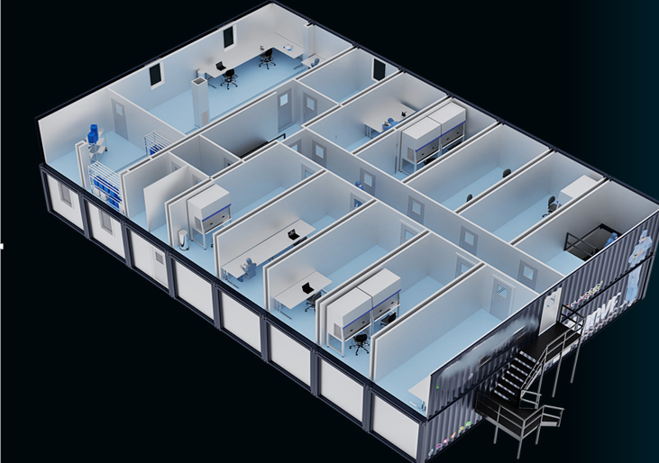



CLEANROOM SOLUTION ISOPOD KLENSYSCUBE KLENSYSWARE KLENSYSTECH
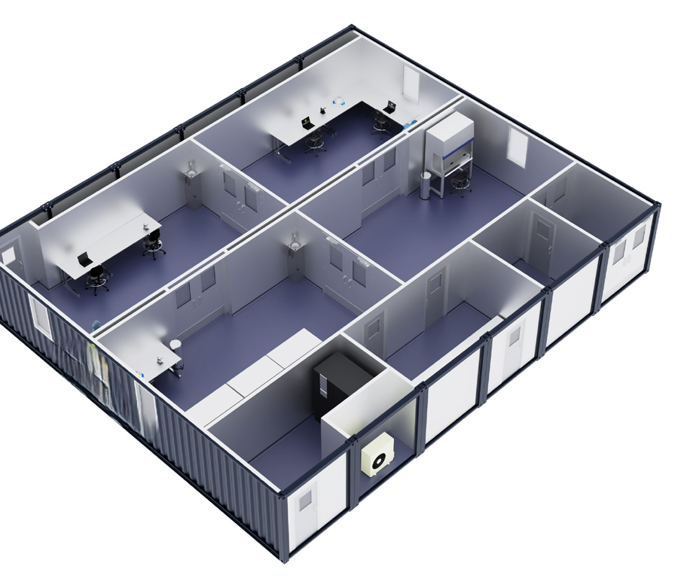
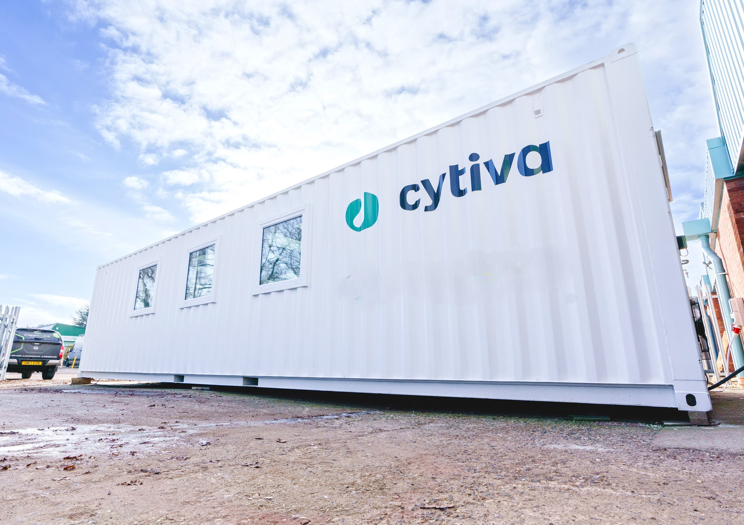

LEdAN controlled environment solutions.
MOBILE CLEANROOM
Cleancube Mobile Cleanrooms ship worldwide and are ideal for quick turnaround projects, space utilisation and temporary applications.
A full range of customisation allows users to configure these mobile formats to best suit process requirements.
With a wide range of internal finishes and structural, mechanical and electrical specification choices, Cleancube can be rapidly designed and manufactured to meet
User Requirement Specification (URS) significantly quicker than conventional builds with the added
benefit that offsite construction offers.
Cleancube Containers
Available in three standard sizes: Mini (20ft – 15m² area), Midi (40ft – 30m² area) and Maxi 2 (40ft double – 60m² area). Shipped globally as stackable modules via highly economical stand-ard shipping channels.
Cleancube Maxi
Utilising 40ft shipping containers joined side by side, Cleancube Maxi can cre-ate facilities with an unlimited footprint.
Cleancube Vehicle Conversions
3.5 and 7.5-ton vehicles internally fitted out to function as fully operational plug & play mobile cleanrooms and labs.

BASE MODEL
- DOORS - Choice of doors available: rapid rise doors – PVC curtain with stainless frame and GRP or powder-coated steel personnel doors with stainless steel push plate, kick plate and handle with 400mm x 400mm vision panel. All Guardtech doors can be electromagnetically interlocked. Also available as a fully flush system with recessed base for flooring to cove into.

- GLAZING - Fully-flush or semi-flush glazing between rooms. Doubled-glazed units can also be installed in the container shell but these are only for UK applications

- WALLS - Powder-coated CR4 mild steel panels with polyisocyanurate (PIR) insulated core and interlocking joints. The panels feature a 50mm thickness to form walls and ceiling. Highly durable, cleanable and chemically resistant, the walls are silicon sealed.

- CEILING - Panelled ceiling with thermal insulation core provides a flush surface. Lighting and filtration modules are recessed into apertures or surface mounted for laboratory applications

- FLOORING - Homogenous vinyl floor reinforced with cross-linked polyurethane, UV-cured, hot-welded joints. Coved 100mm up the wall over underlay former and capped. Copper-grounded anti-static vinyl also available.

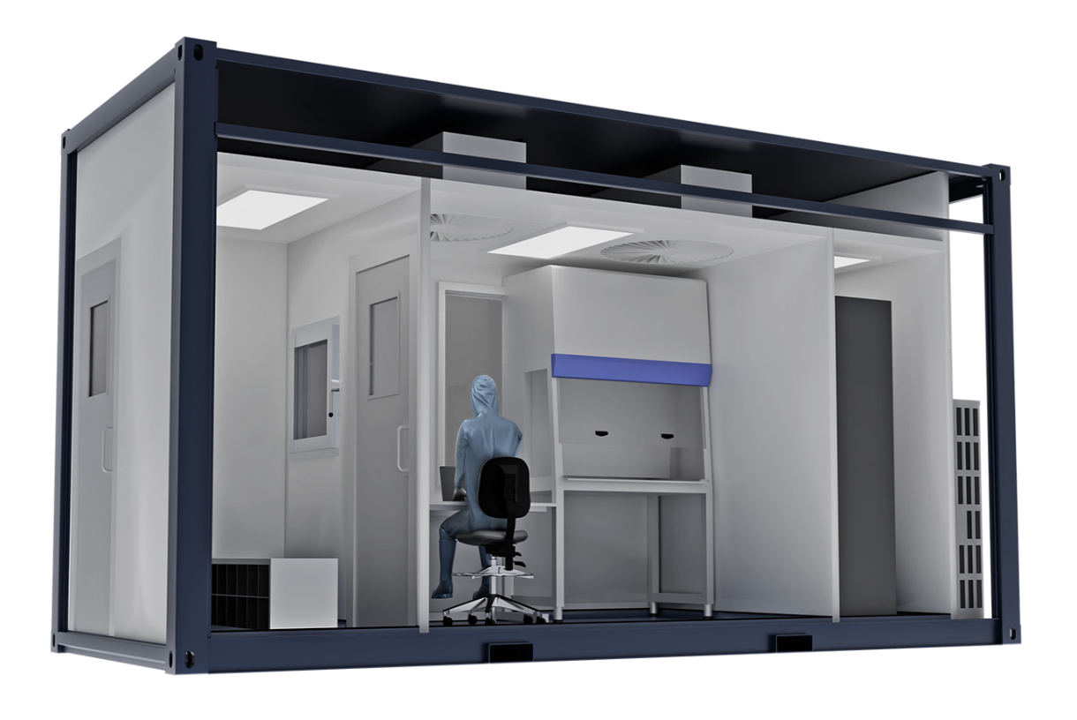

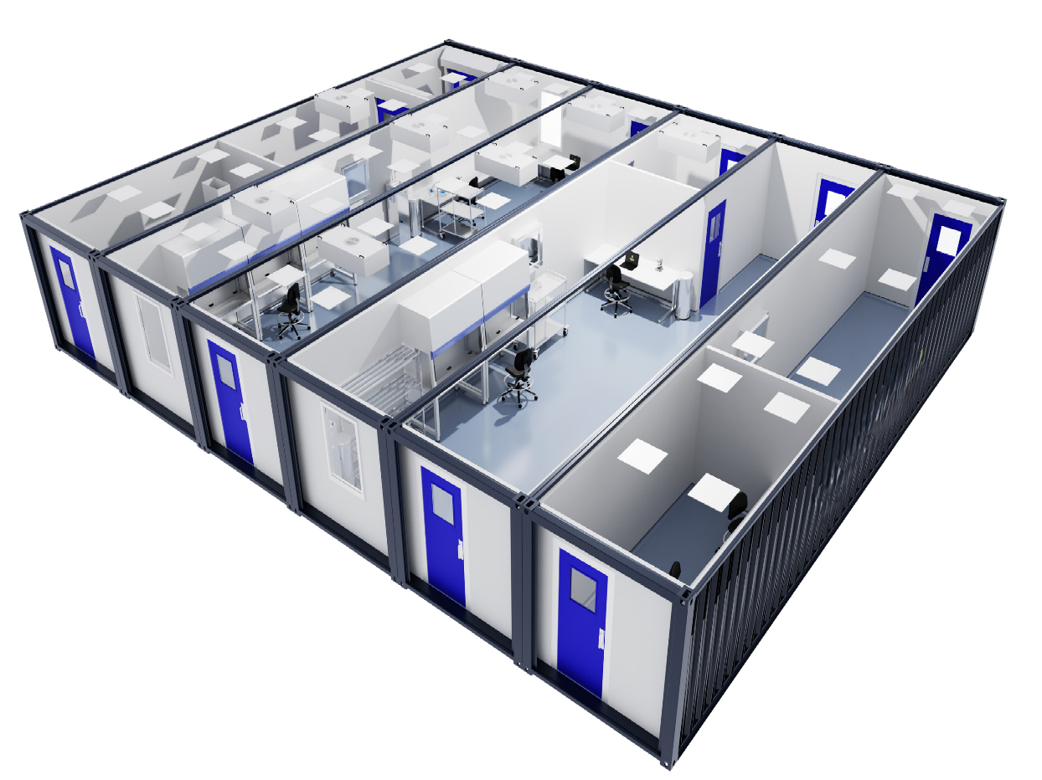
CUBE: a comprehe Panelled ceiling w

- CONNECTION - Cleancube Maxi utilises open-sided 40ft shipping containers joined along their longest edge. This enables unlimited con-nection of modules in 12 metre bays to provide an open plan or divided facility layout. Modules are manufactured as inde-pendent units that connect on site – this allows for quick instal-lation, easy relocation and the potential for facility expansion by adding an infinite number of units. Connection is made with a proprietary system that ensures water tightness and building integrity whilst also allowing seamless connection of internal components, utilities and plant.

Configurations - 2-metre (40ft) or 6-metre (20ft) bays of 2.5m width can be linked continuously to create the desired facility footprint. Internally, these facilities can be configured as per any traditional modu-lar cleanroom build. The flexibility that this provides enables clients to create un-restricted configurations for of standard on-site con-struction. The Cleancube Design team will work with you to create cleanroom layouts that meet your process demands whilst also ensuring the principles of interconnectivity for each module are well considered and allow each bay to be independently constructed,

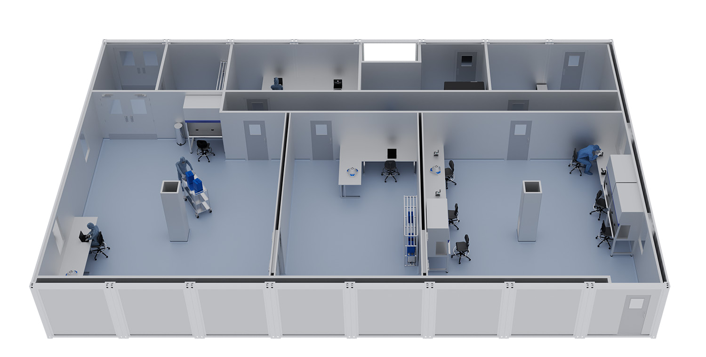
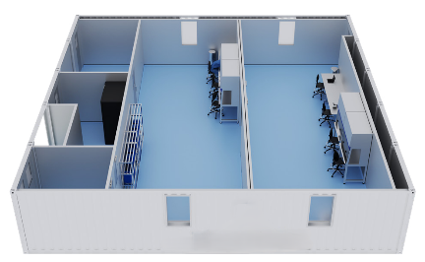
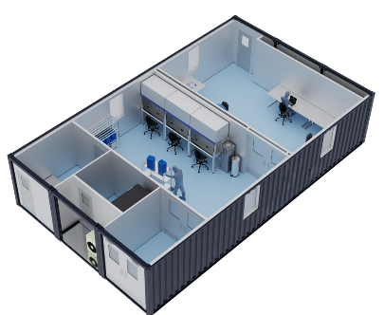
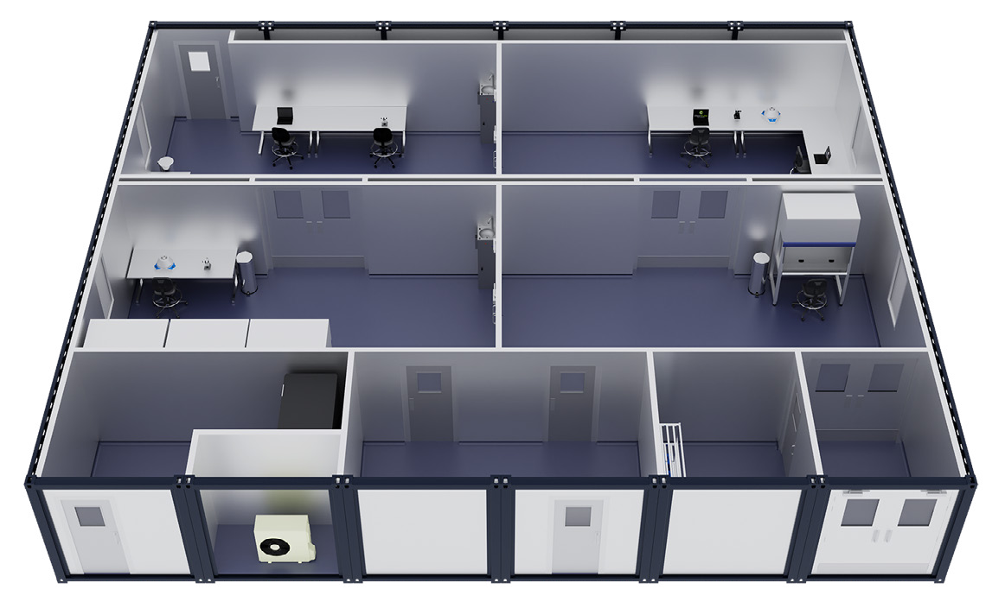
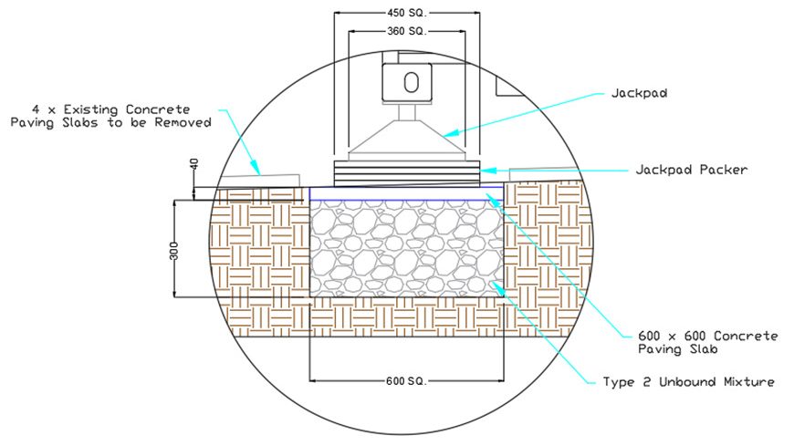
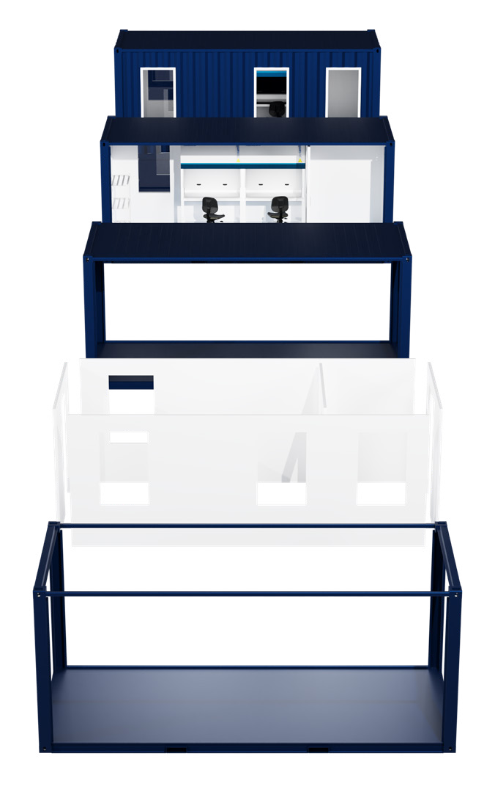
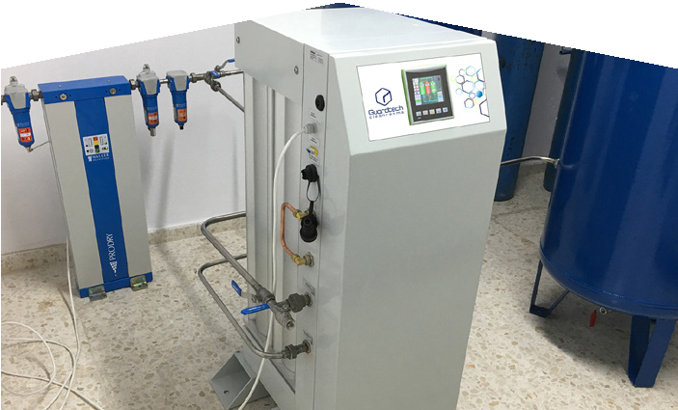
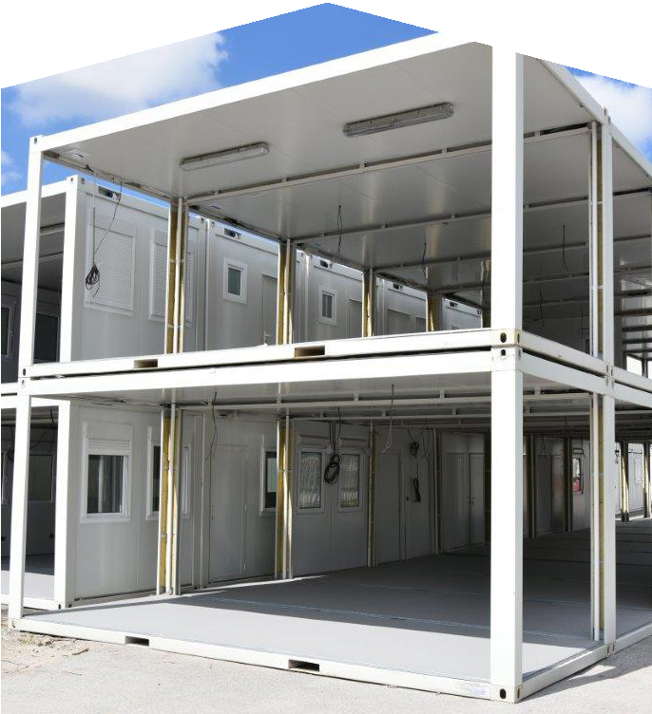
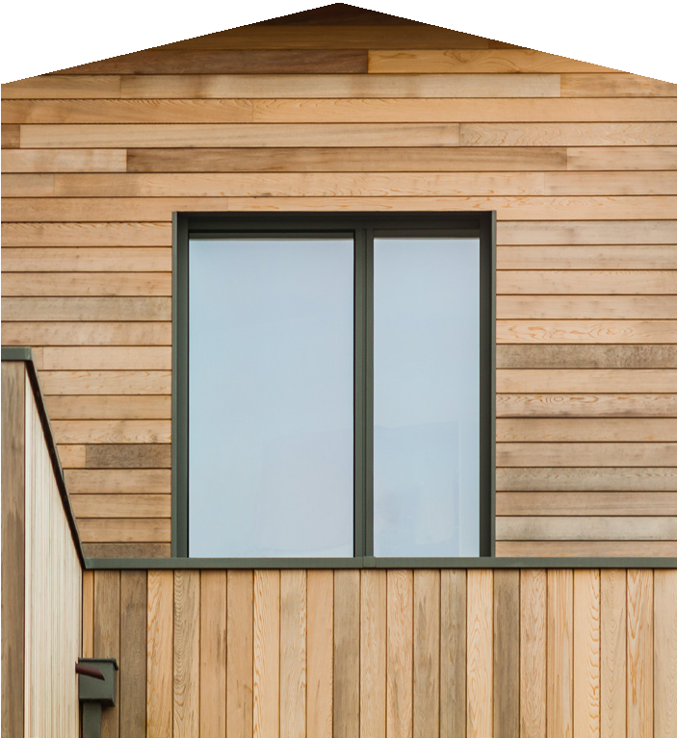
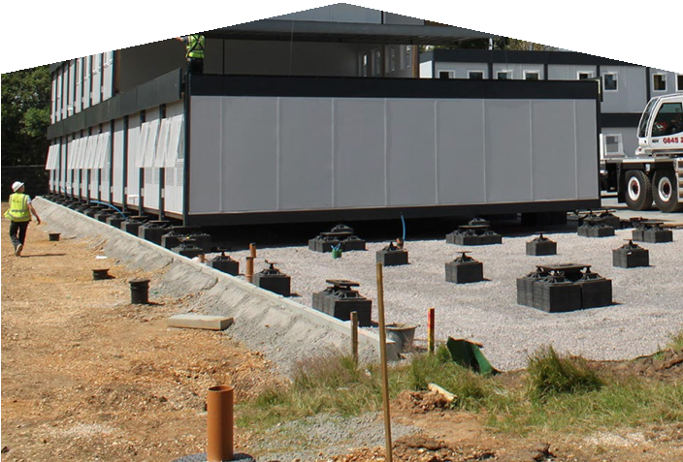
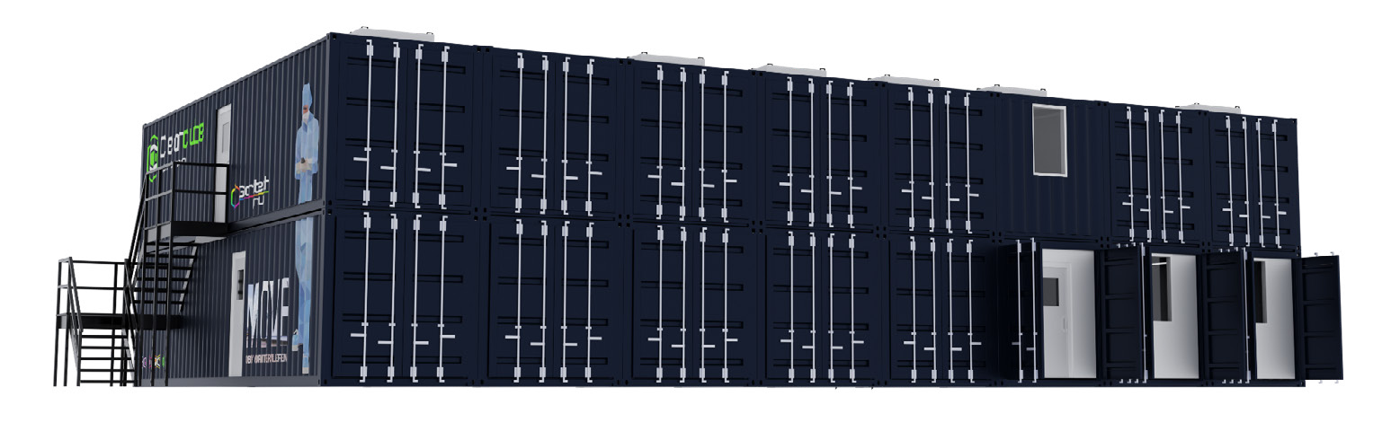
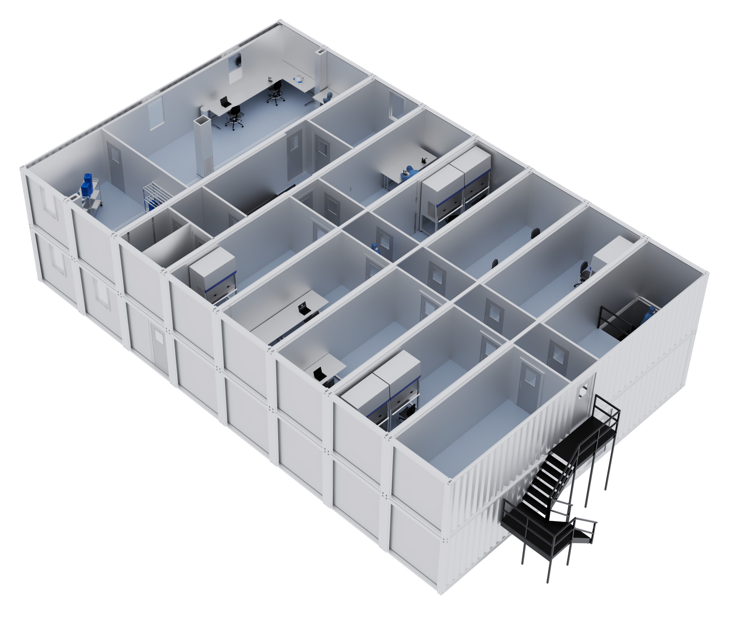
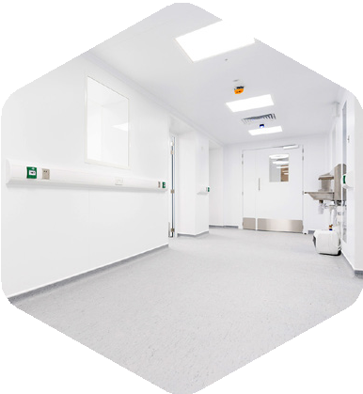
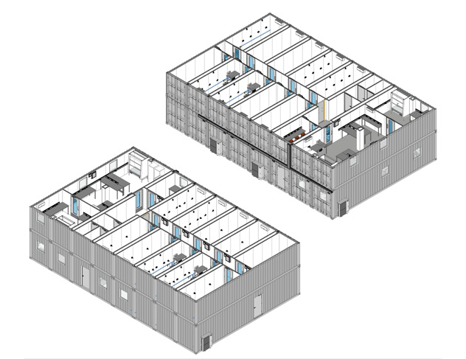
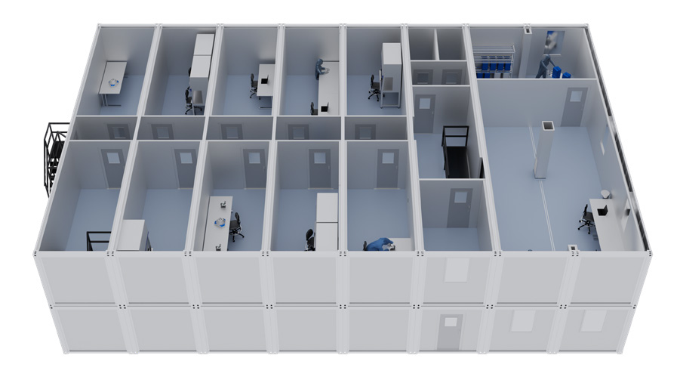
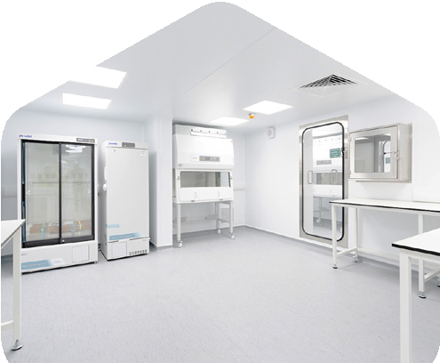
ith thermal insulation flush core provides a surface. Lighting filtration recessed into apertures or ereref mounted for lab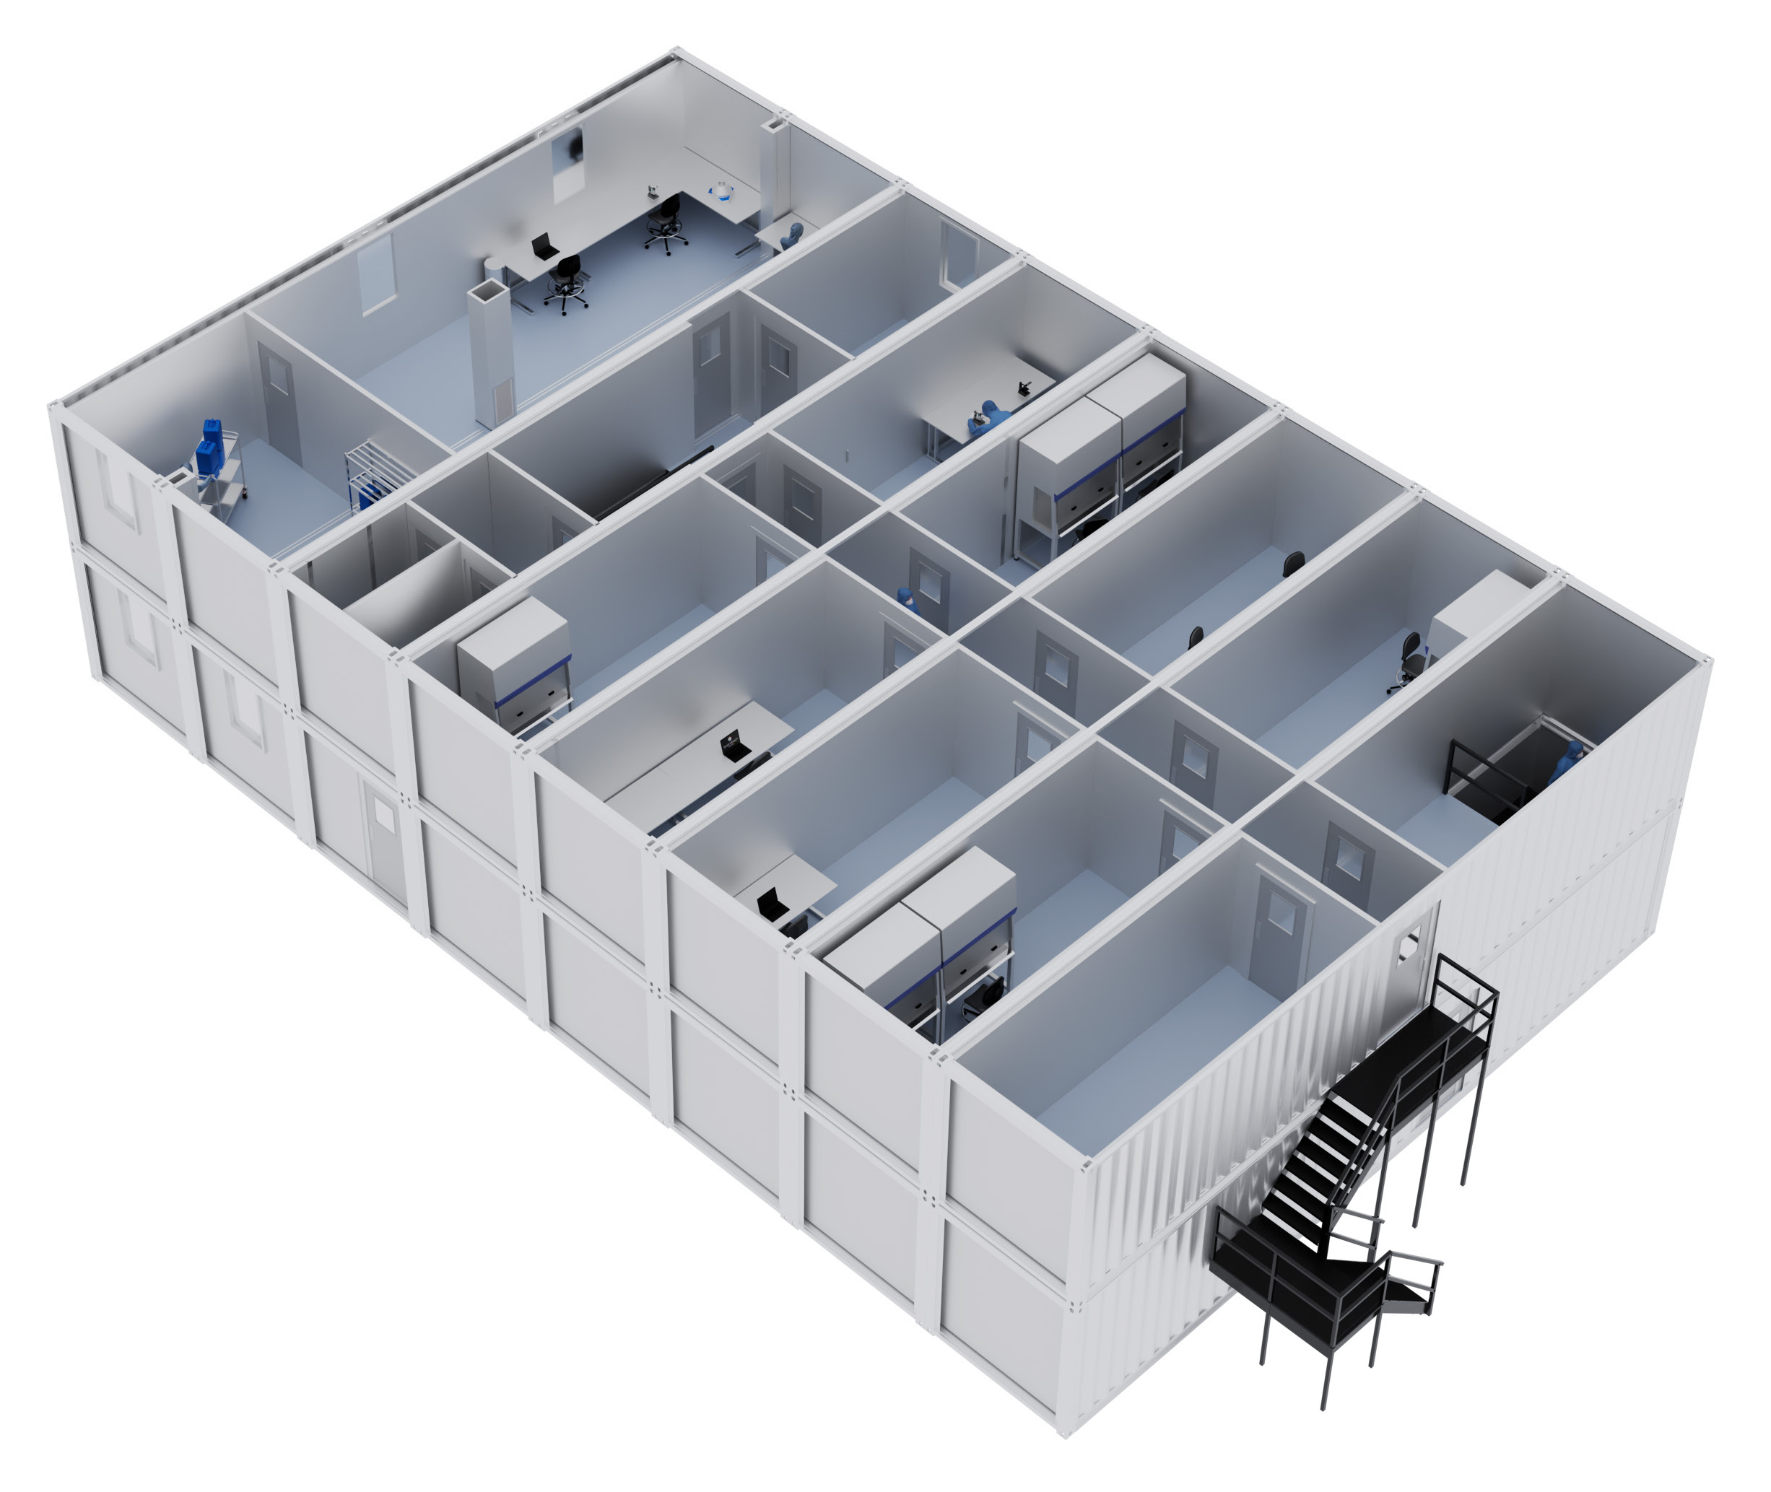oratory applications nsive portfolio of plBAug & play portable
KEY INFORMATION
External Shell 8 x 40ft high cube steel contain-ers (conjoined)
External Dimensions 12,192mm (L) x 19,504mm
(W) x 2,896mm (H)
Number Of Rooms 9 (plus corridor) Total Weight Approximately 48,000kg
Power & Network 29 x 13-amp double sockets and 14 x CAT6 data outlets
KEY INFORMATION
(conjoined ) External Dimensions 12,192mm (L) x 12,190 (W x 2,896mm (H) Number Of Rooms 6 Total Weight Approximately 30,000kg Power & Network 28 x 13-amp double sockets and 13 x CAT6 data outlets
KEY INFORMATION
External Shell 7 x 40ft high cube steel containers (conjoined) External Dimensions 12,192mm (L) x 17,066mm (W) x 2,896mm (H) Number Of Rooms 8 (plus corridor) Total Weight Ap proximately 42,000kg Power & Network 47 x 13-amp double sockets and 25 x CAT6 data outlets

KEY INFORMATION
External Shell 3 x 40ft high cube steel containers (conjoined) External Dimensions 12,192mm (L) x 7,314mm (W) x 2,896mm (H) Number Of Rooms 5
Total Weight Approximately 18,000kg
Power & Network 28 x 13-amp double sockets and 15 x CAT6 data outlets
MAXI 3

KEY INFORMATION
External Shell 6 x 40ft high cube steel containers (conjoined)
External Dimensions 12,192mm (L) x 14,628mm (W) x 2,896mm (H)
Number Of Rooms 7
Total Weight Approximately 36,000kg
Power & Network 39 x 13-amp double sockets and 20 x CAT6 data outlets
KEY INFORMATION
External Shell 4 x 40ft high cube steel containers (conjoined)
External Dimensions 12,192mm (L) x 9,752 (W) x 2,896mm (H)
Number Of Rooms 5
Total Weight Approximately 24,000kg
Power & Network 32 x 13-amp double sockets and 15 x CAT6 data outlets
STACKING All Maxi units are designed and factory assembled to meet the individual requirements of customers. The units can
be stacked to create a two-floor system, with an adjoining staircase connecting the ground and first floors. The Cleancube team will be more than happy to discuss
any particular configuration requirements you have.

Multi
Take your shipping container cleanroom facility to another level with Cleancube Multi.
Simply tell us what kind of base footprint you require for the ground layer, then keep stacking modules on top to increase the overall size of the facility.
Cleancube Multi levels are connected via internal and external staircases.
We’ll work with you and specialist third party struc-tural engineers to ensure each module is safe to carry whatever process equipment or furniture you require to meet the needs of your application.
Offering clients high-quality internal fit-outs built to the same specification as the rest of the Guardtech Group’s range of cleanroom solutions, with all plant and utilities fully incorporated, Cleancube Multi is the future of large-scale modular cleanroom construction.

With Cleancube Multi, we’re essentially taking the award-winning Cleancube Maxi system to new lev-els. Stack as many modules as you want to boost your footprint to the optimum size. With a range of internal and external staircases available, as well
as lift systems, moving personnel, materials and equipment around is a breeze.

ISOLATOR INTEGRATION
Typically, the heart of the process, isolator selection is fundamental for these critical environments. Guardtech work with a number of manufacturers to incorporate isolators that best meet your process demands and user preferences.
- Range of isolator manufacturers
- Pre-installed at manufactured facility
- Extraction and ventilation incorporated
- VHP transfer protocol consid-ered
- Fully commissioned with ongoing Service Contract

ANNEX 1 MATERIAL TRANSFER COMPLIANCE
Intelligent consideration must be given when reviewing the transfer path of all incoming materials and outgoing goods. Where possible, Guardtech will reduce the space required for material transfer to meet the bare minimum demands,
allowing process space to be the dominant occupant. Transfer between classifications performs safely via H14 ventilated hatches.
- Bespoke transfer or trolley hatch configurations
- HEPA filtered active ventilation
- Electro-magnetic interlocks
- Grade 316 corner-less con-struction
- Double or triple stack hatches available

\

CHANGING ARRANGEMENT

The recent changes to Annex 1 guidance have resulted in an increased consideration for changing spaces between grades and separated room entry and exit. Guardtech have crafted some intelligent workarounds to ensure compliance whilst minimising impact on footprint.
- Bespoke stepover configurations
- Gowning SOP support
- Intelligent storage solutions

PRESSURE REGIMES
A significant portion of aseptic pharmaceutical manufac-turing relates to chemotherapy drugs. Balancing operator safety via containment against effective contamination control measures is the fundamental consideration for processing spaces. A mixture of positively and negatively pressurised rooms achieves the best outcome.
- Dedicated air supplies for individual processing suites
- Intelligent control systems for pressure balancing
- Highly accurate environmental monitoring systems
- Highly sealed rooms with air leakage rates incorporated into design

\

ANNEX 1 MATERIAL TRANSFER COMPLIANCE
Intelligent consideration must be given when reviewing the transfer path of all incoming materials and outgoing goods. Where possible, Guardtech will reduce the space required for material transfer to meet the bare minimum demands,
allowing process space to be the dominant occupant. Transfer between classifications performs safely via H14 ventilated hatches.
- Bespoke transfer or trolley hatch configurations
- HEPA filtered active ventilation
- Electro-magnetic interlocks
- Grade 316 corner-less con-struction
- Double or triple stack hatches available


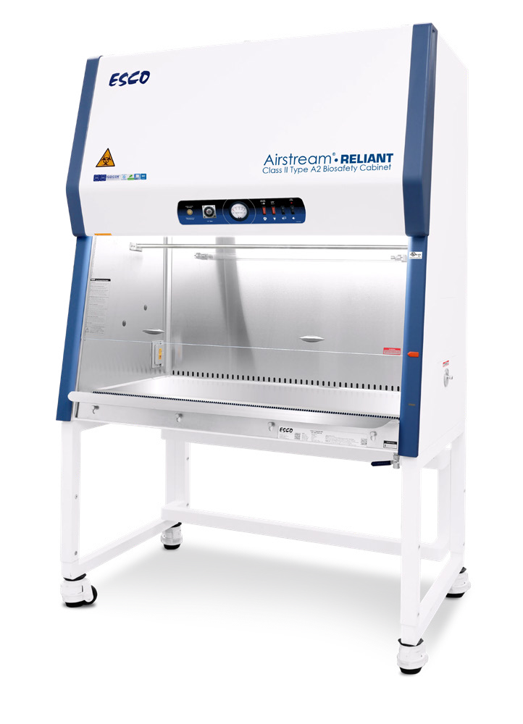

CL3
When designing a CL3 (Class 3) containment cleanroom, which is typically used in environments requiring high levels of containment for hazardous biological materials (like certain pathogens, viruses, or biotechnology prod-ucts), there are several important specification design considerations.
Cleancube CL3 cleanrooms adhere to strict regulatory and safety standards to prevent contamination and pro-tect workers, the environment, and the products being manufactured or studied.

Fully vinyl wrapped
wall to floor detail

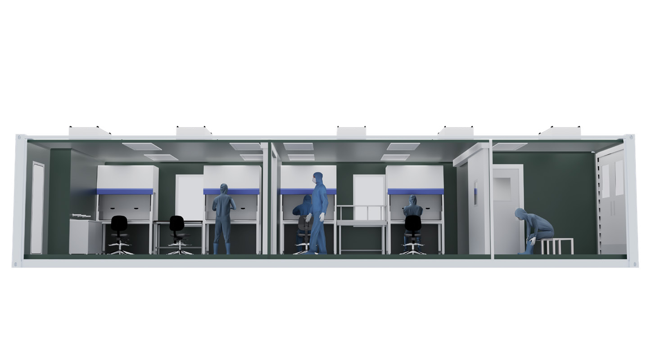

CL3 Cleancube facilities utilise most of the materials of construction used for standard cleanroom building. Howev-er, a significant variation is that all walls, ceilings and floors are continuously vinyl wrapped with fully welded seams and coved formers at all corner joints.
● Homogenous 2mm antimicrobial vinyl
● Coved corner joints
● All interfacing materials fully silicone sealed
● Room full pressure/leak tested during commissioning stage

Controlling contaminated air is vital for public safety and there-fore the units operate on 100% fresh air with filtration at point of supply and on exhausts and forced extraction.
- Safe change H14 filtration on exhausts
- Local exhaust ventilation (LEV) installed on all separative devices
- Heat recovery systems allow expulsion of contaminated air with recovery of energy
- Humidity control possible but tight tolerance expensive to achieve

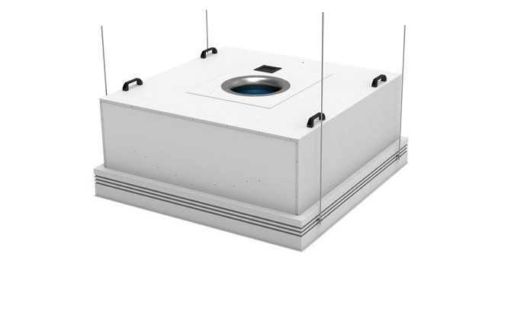
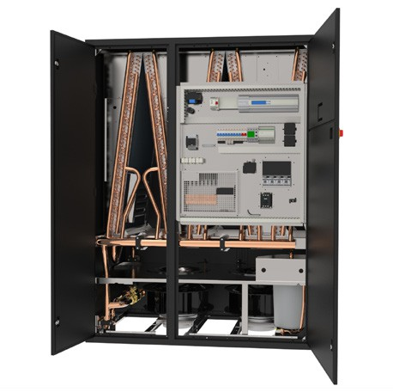

FILTRATION HVAC

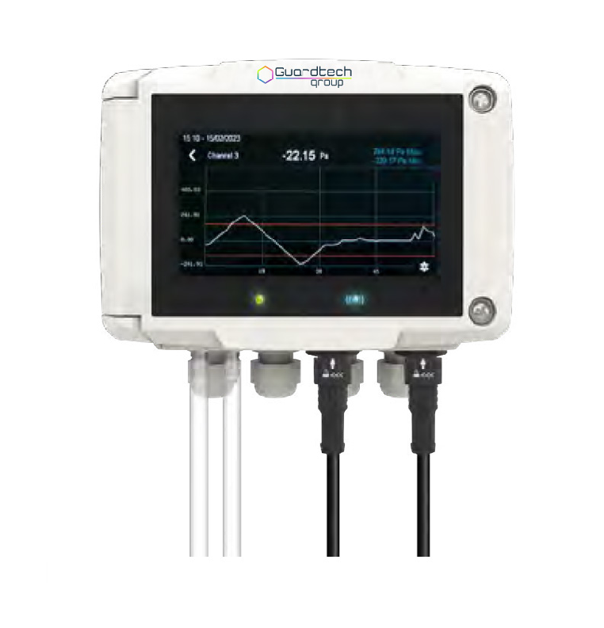

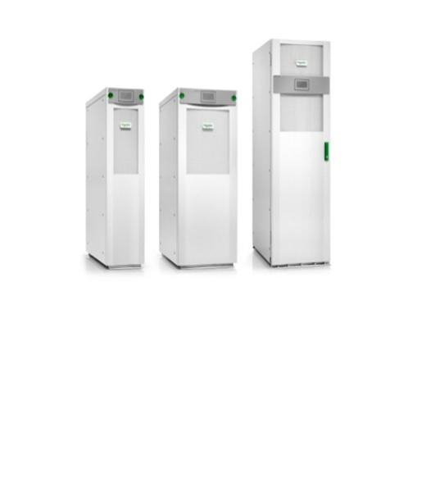 EMS
POWER MANAGEMENT

